**WEEK - 2 : HANDS-ON EXERCISE**

**TDD using JUnit5 and Mockito**

**1. JUnit Basic Testing Exercises**

**Exercise 1: Setting Up Junit**

**Scenario:**

* You need to set up JUnit in your Java project to start writing unit tests.

**Step 1: Create a new folder**

1. Open Visual Studio Code.
2. Create a new folder and name it JUnitSetup.
3. Inside JUnitSetup, create two subfolders:

* src → for source code
* lib → for external JAR fil

**Step 2: Download JAR files**

Download and place the following JAR files inside the lib/ folder:

* junit-4.13.2.jar
* hamcrest-core-1.3.jar

**Step 3: Create Calculator.java**

**CODE:**

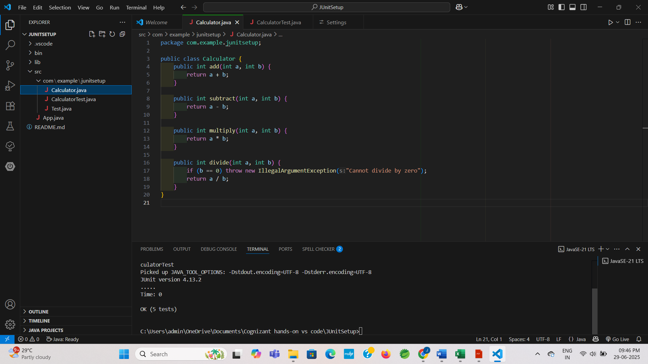

**Step 4: Create CalculatorTest.java**

**CODE:**

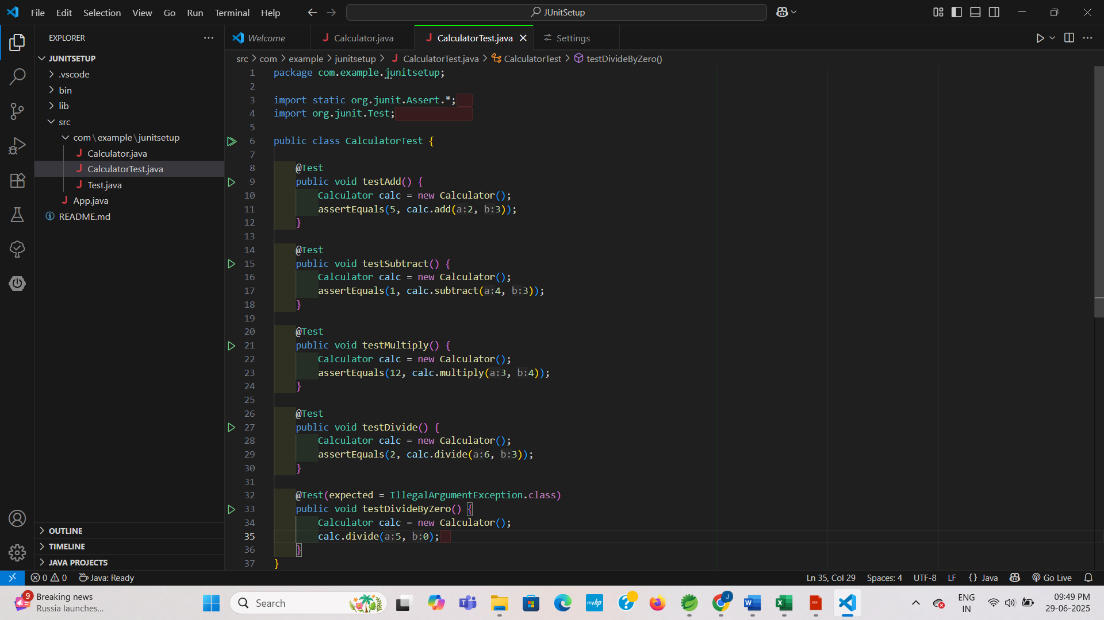

**OUTPUT:**

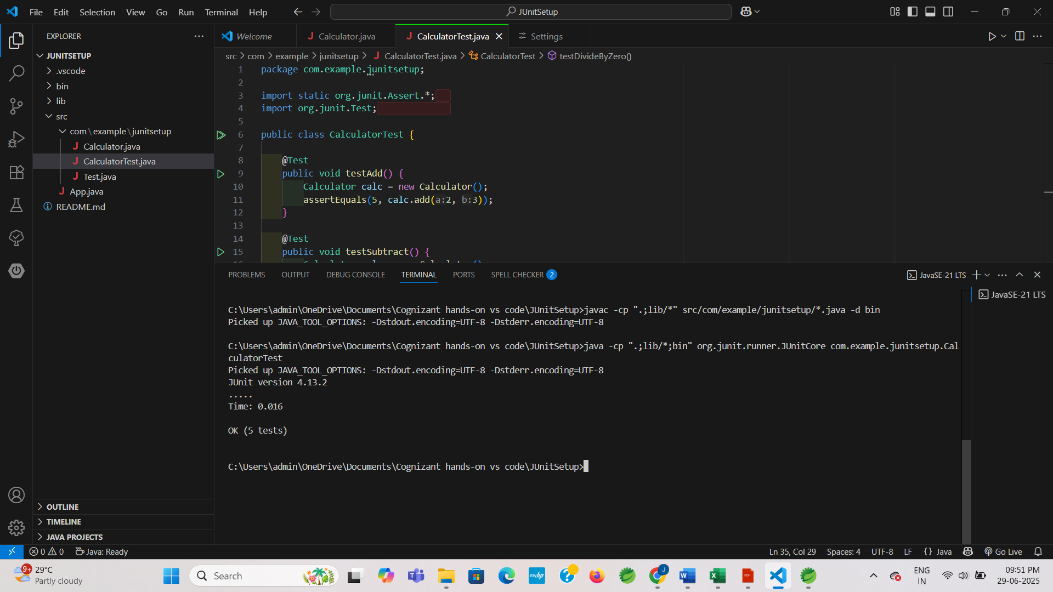

**Exercise 3: Assertions in JUnit**

**Scenario:**

* You need to use different assertions in JUnit to validate your test results.

**Step 1 : AssertionsTest.java**

**CODE:**

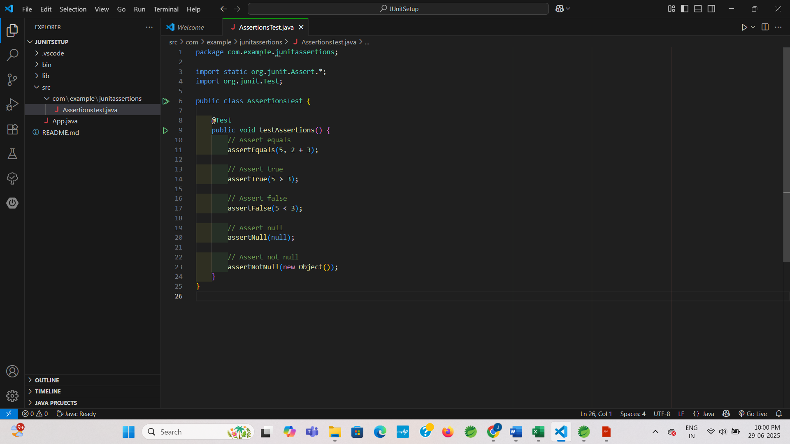

**OUTPUT:**

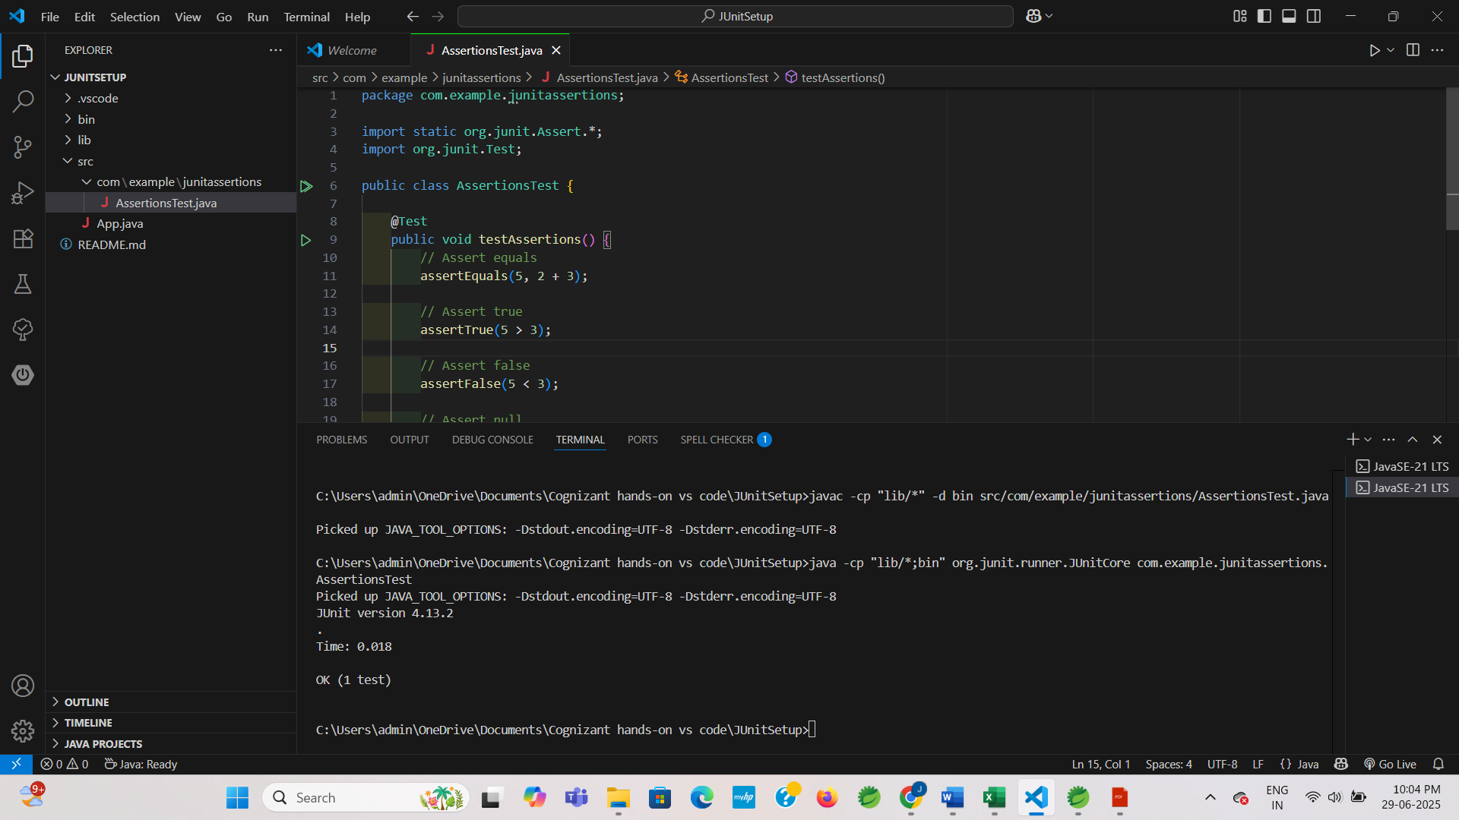

**Exercise 4: Arrange-Act-Assert (AAA) Pattern, Test Fixtures, Setup and Teardown Methods in Junit**

**Scenario:**

* You need to organize your unit test logic using the Arrange-Act-Assert (AAA) pattern. You should also use @Before and @After annotations to prepare and clean up resources before and after each test.

**Step 1 : BankAccount.java**

**CODE:**

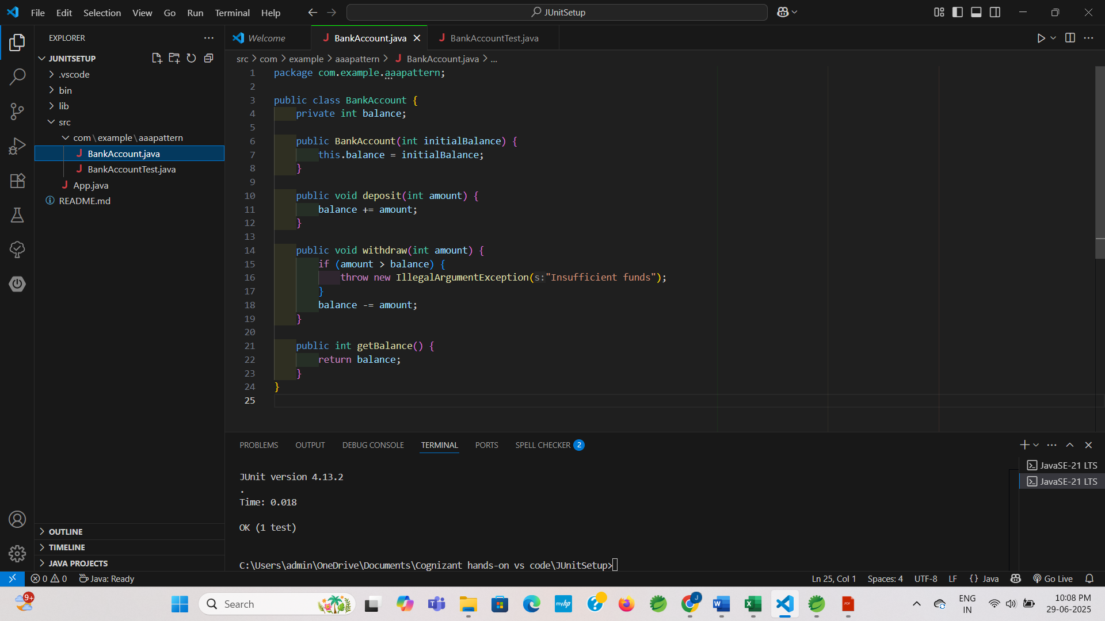

**Step 2 : BankAccountTest.java**

**CODE:**

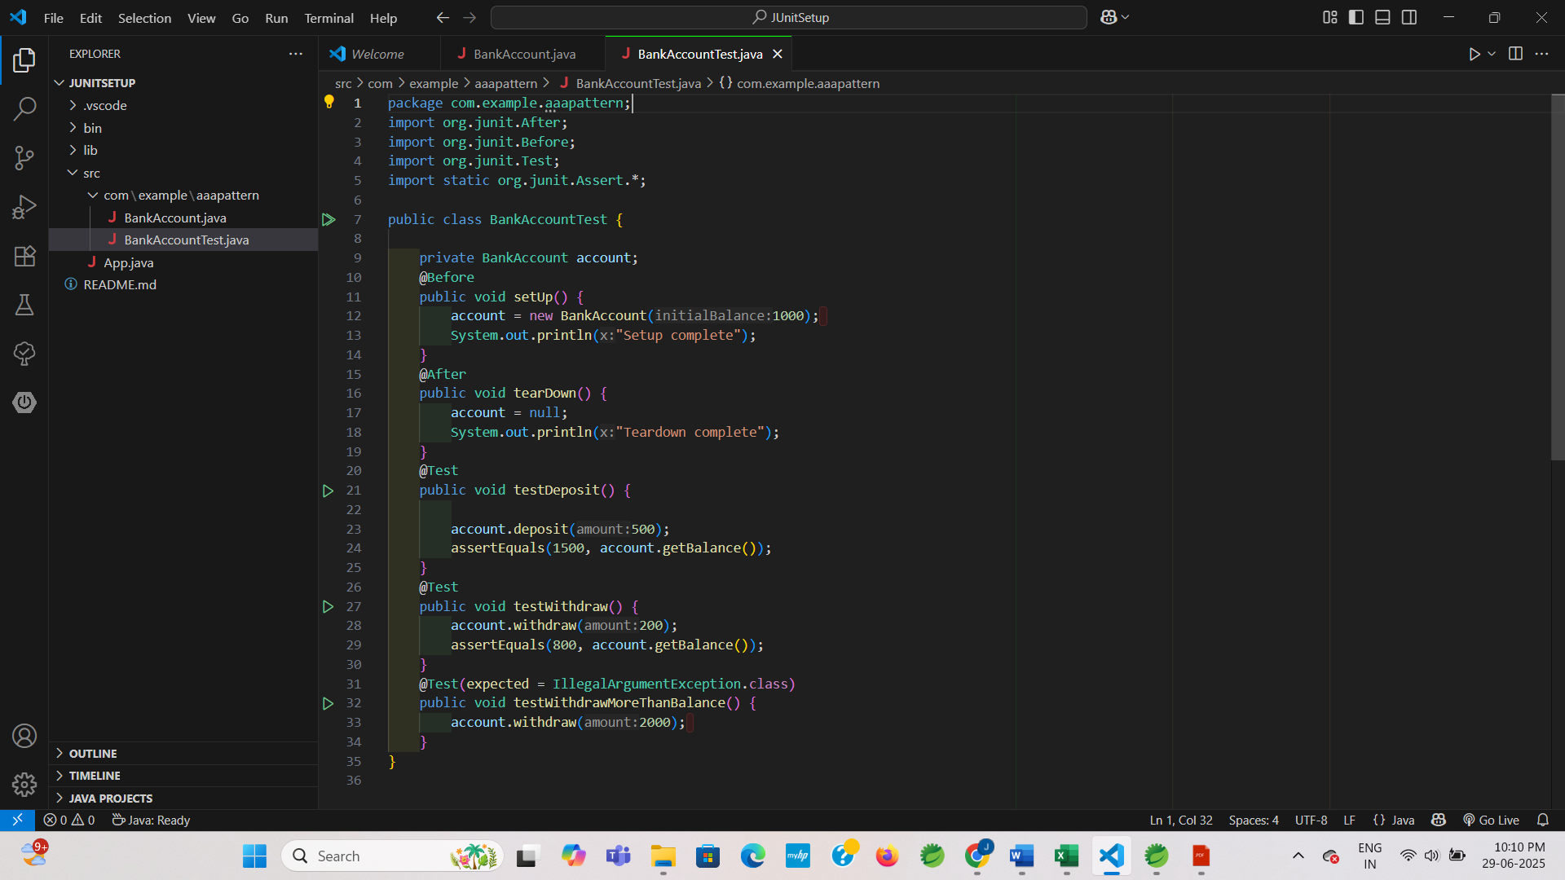

**OUTPUT:**

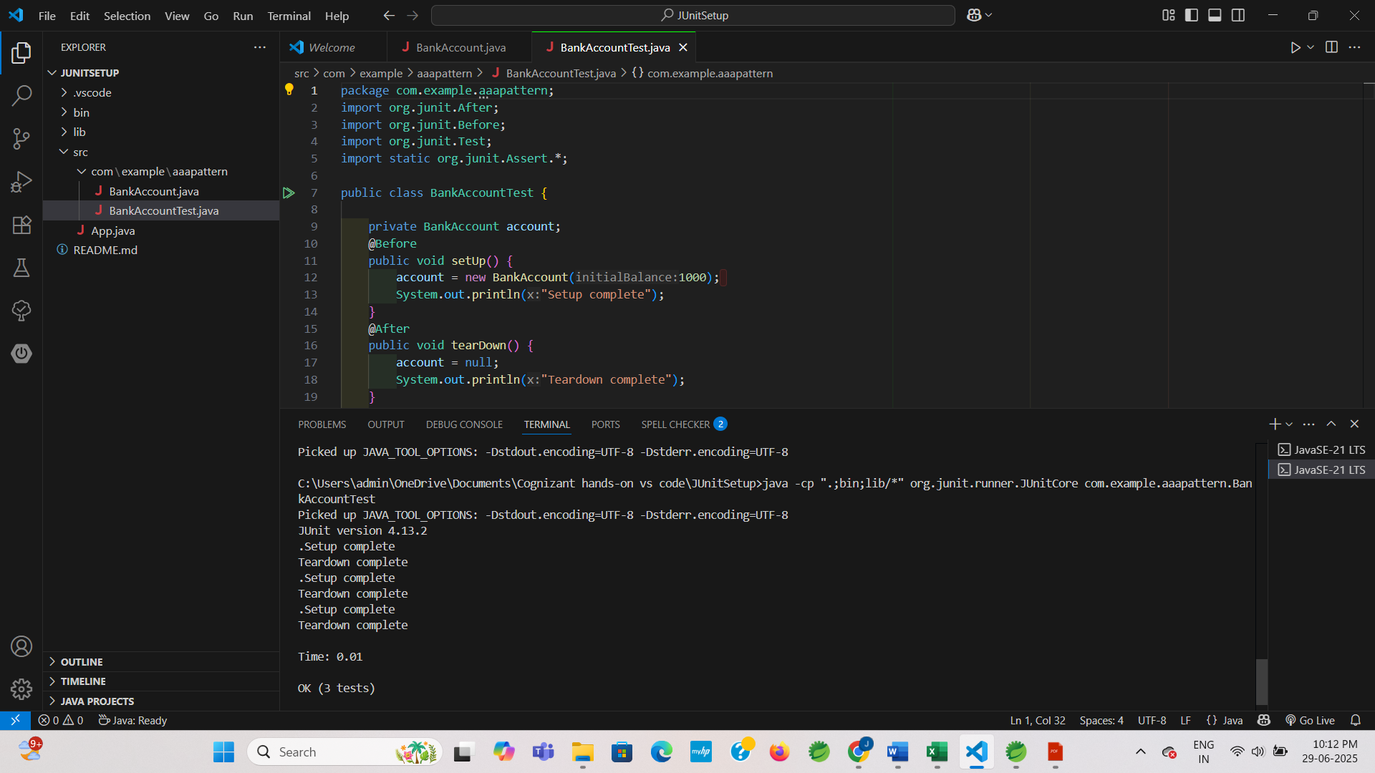

**2. Mockito exercises**

**Exercise 1: Mocking and Stubbing**

**Scenario:**

You need to test a service that depends on an external API. Using Mockito, you'll mock the external API and stub its method to return predefined values.

**Step 3: ExternalApi.java**

**CODE:**

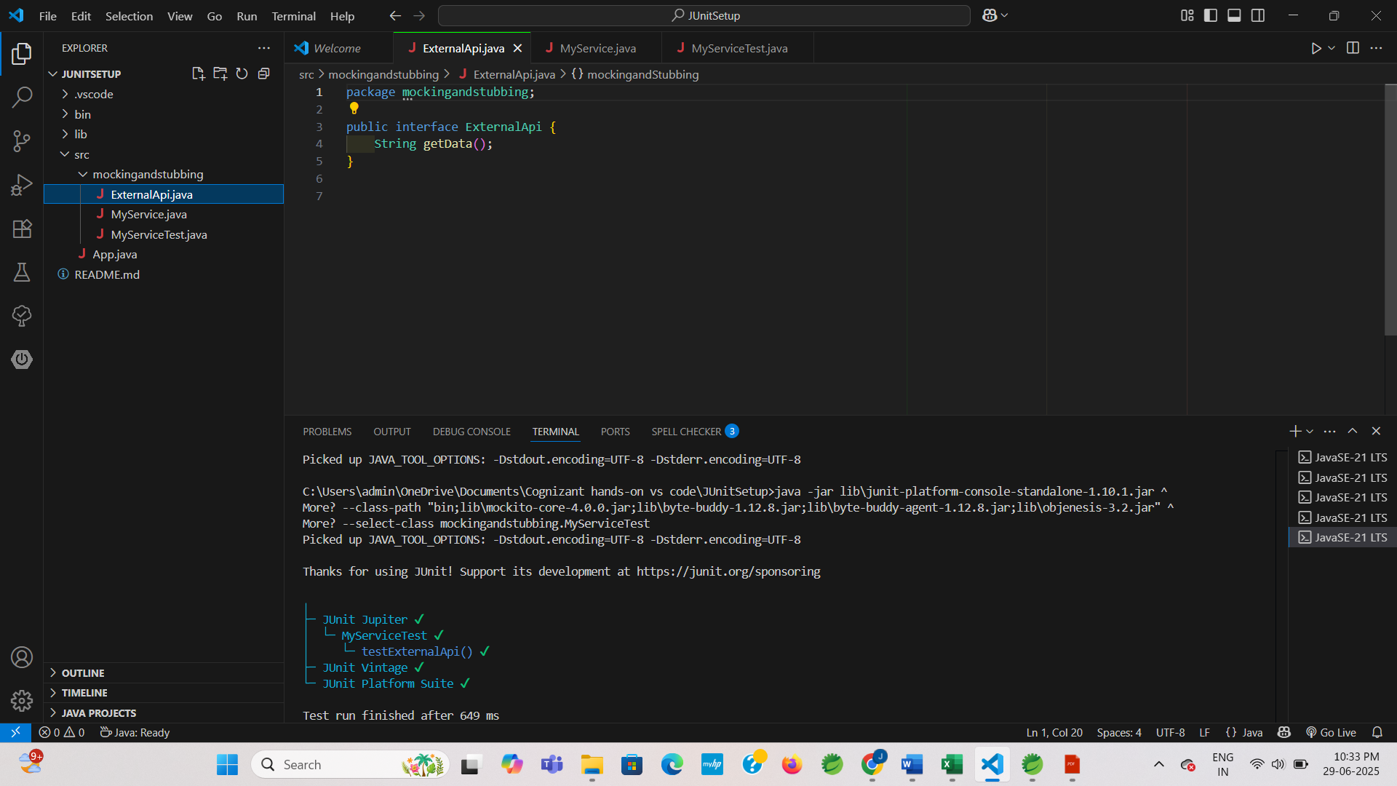

**Step 4: MyService.java**

**CODE:**

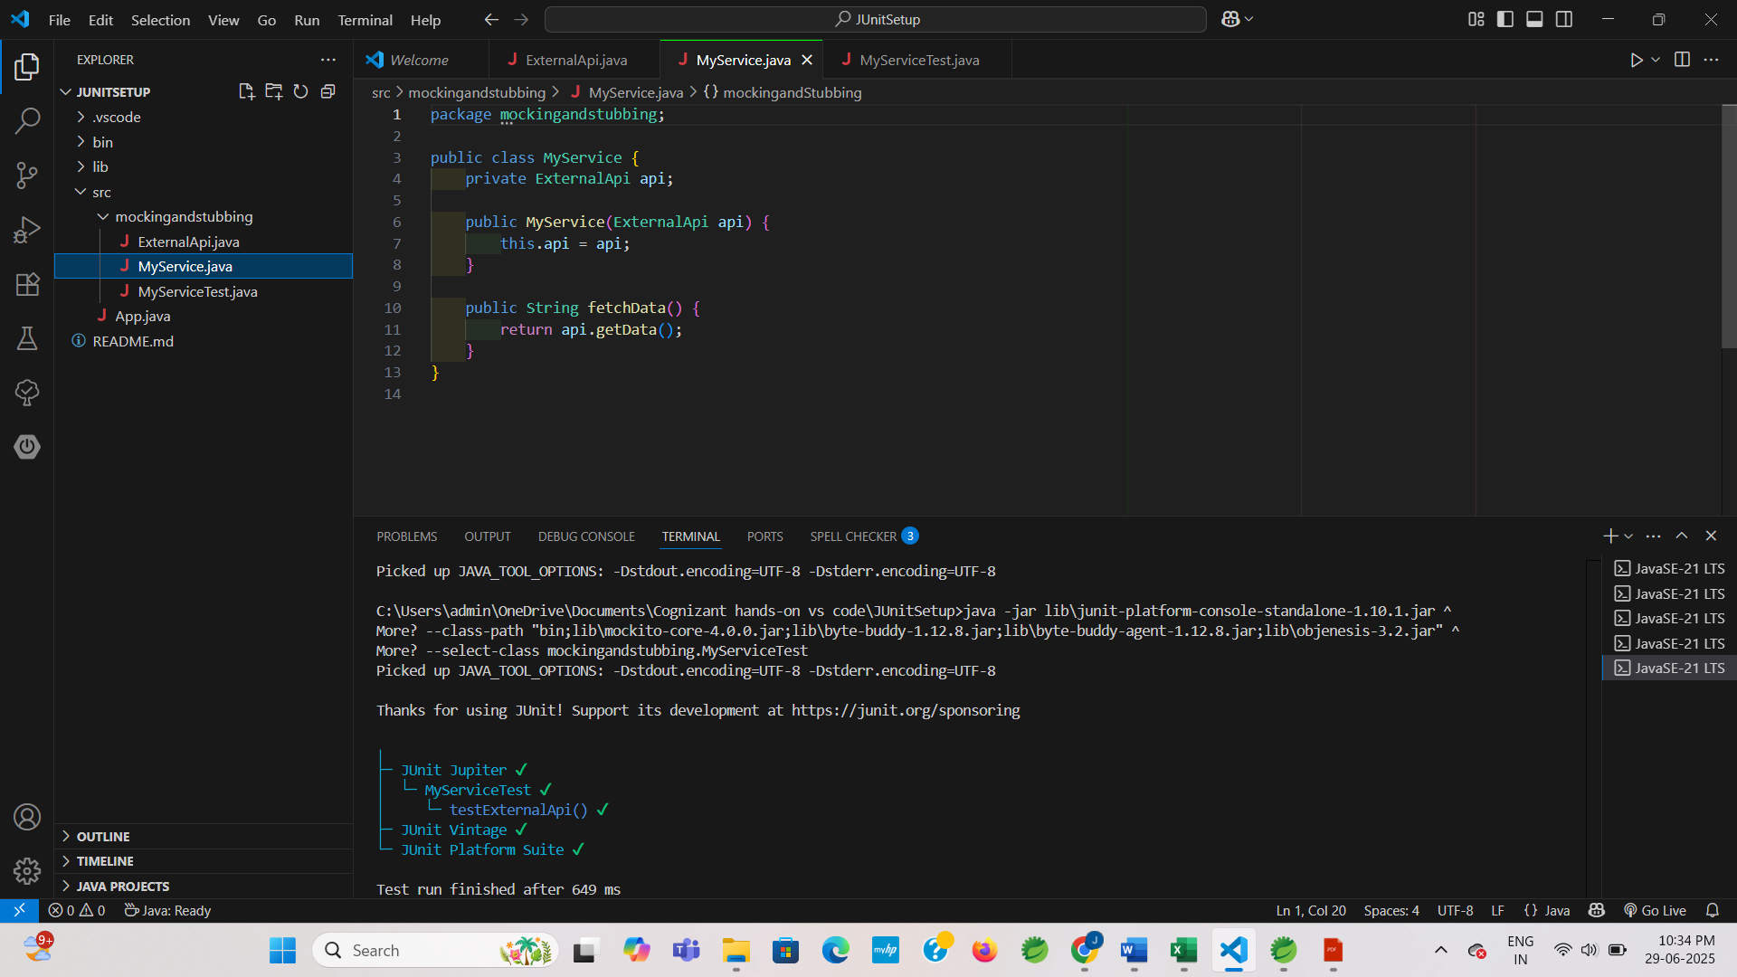

**Step 5: MyServiceTest.java**

**CODE:**

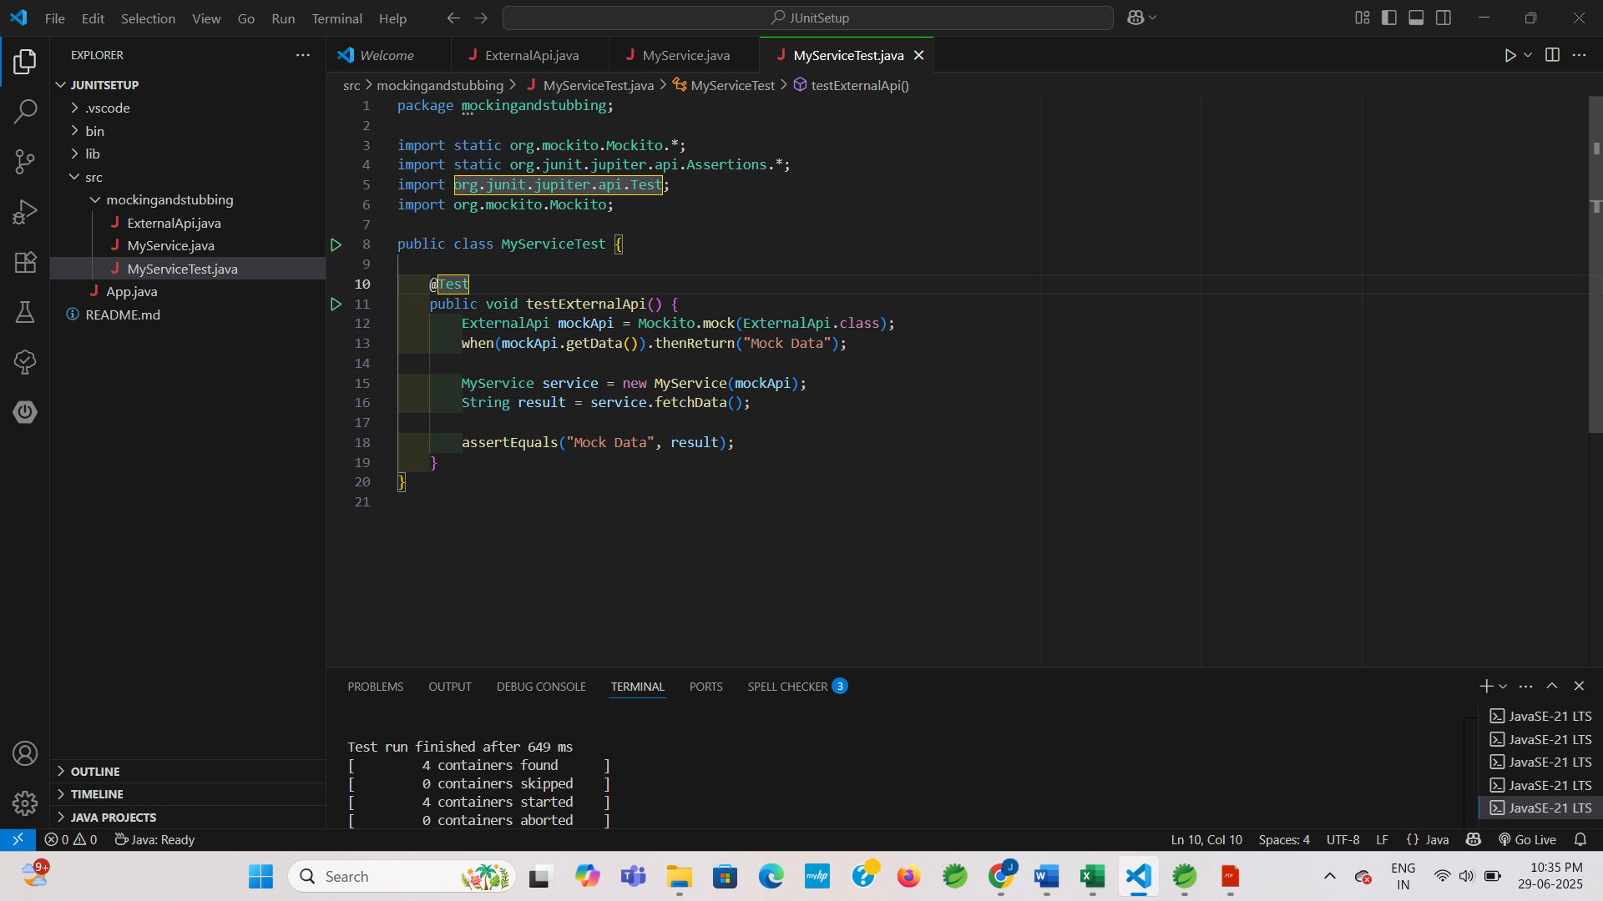

**OUTPUT:**

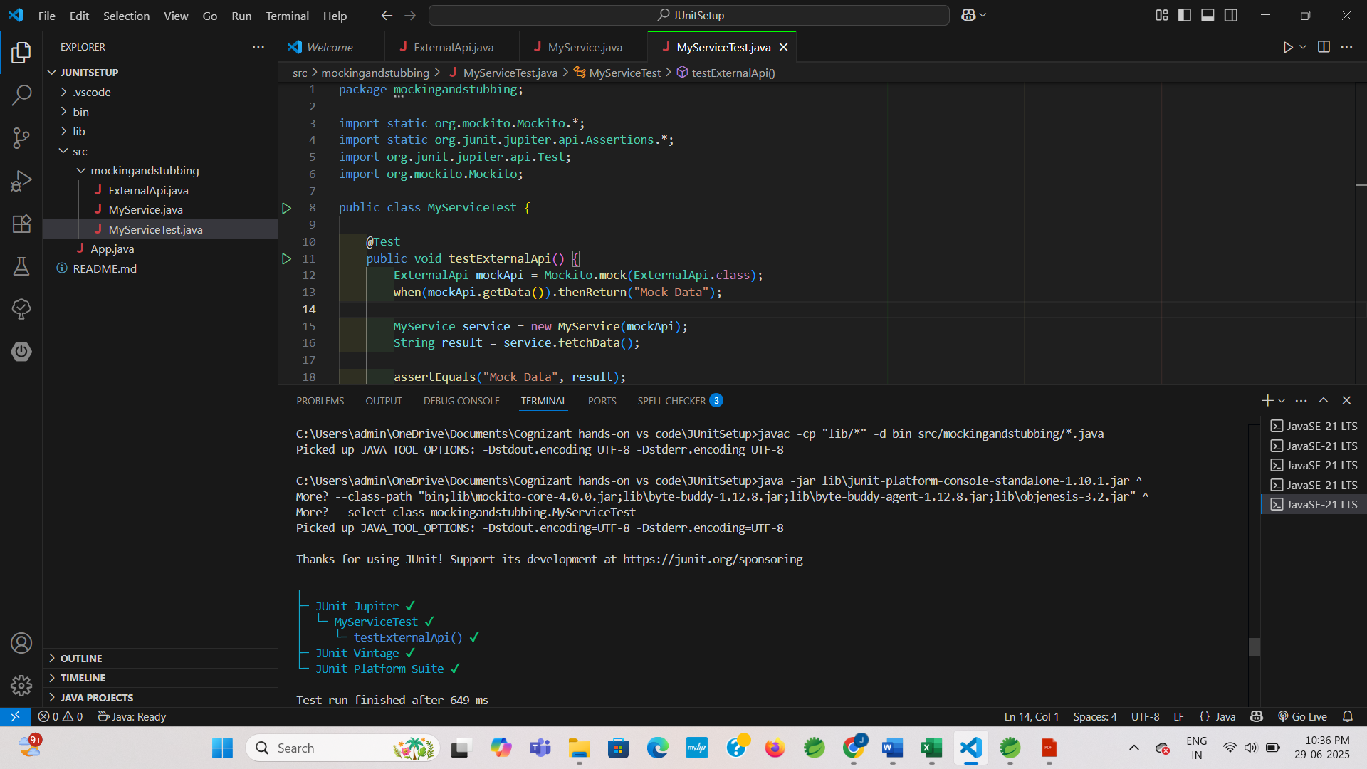

**Exercise 2: Verifying Interactions**

**Scenario:**

Verifying Method Calls on a Mock Object

**Step 3: ExternalApi.java**

**CODE:**

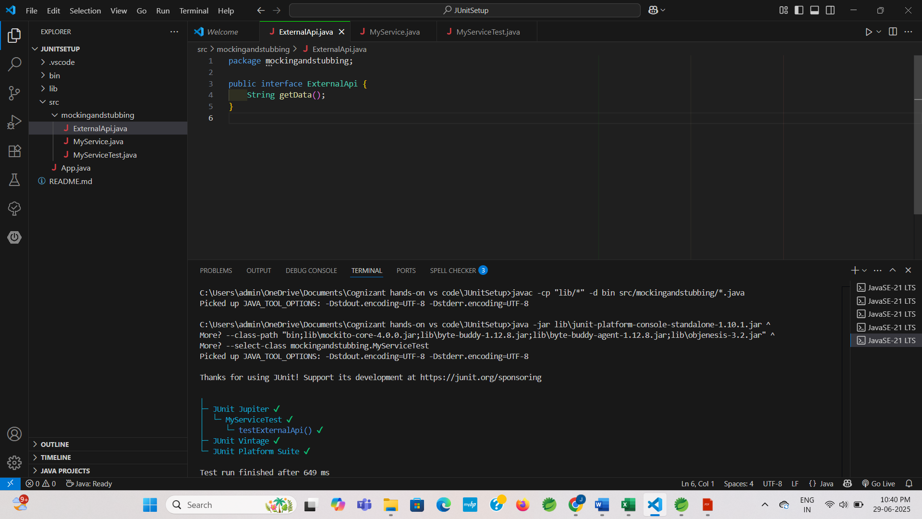

**Step 4: MyService.java**

**CODE:**

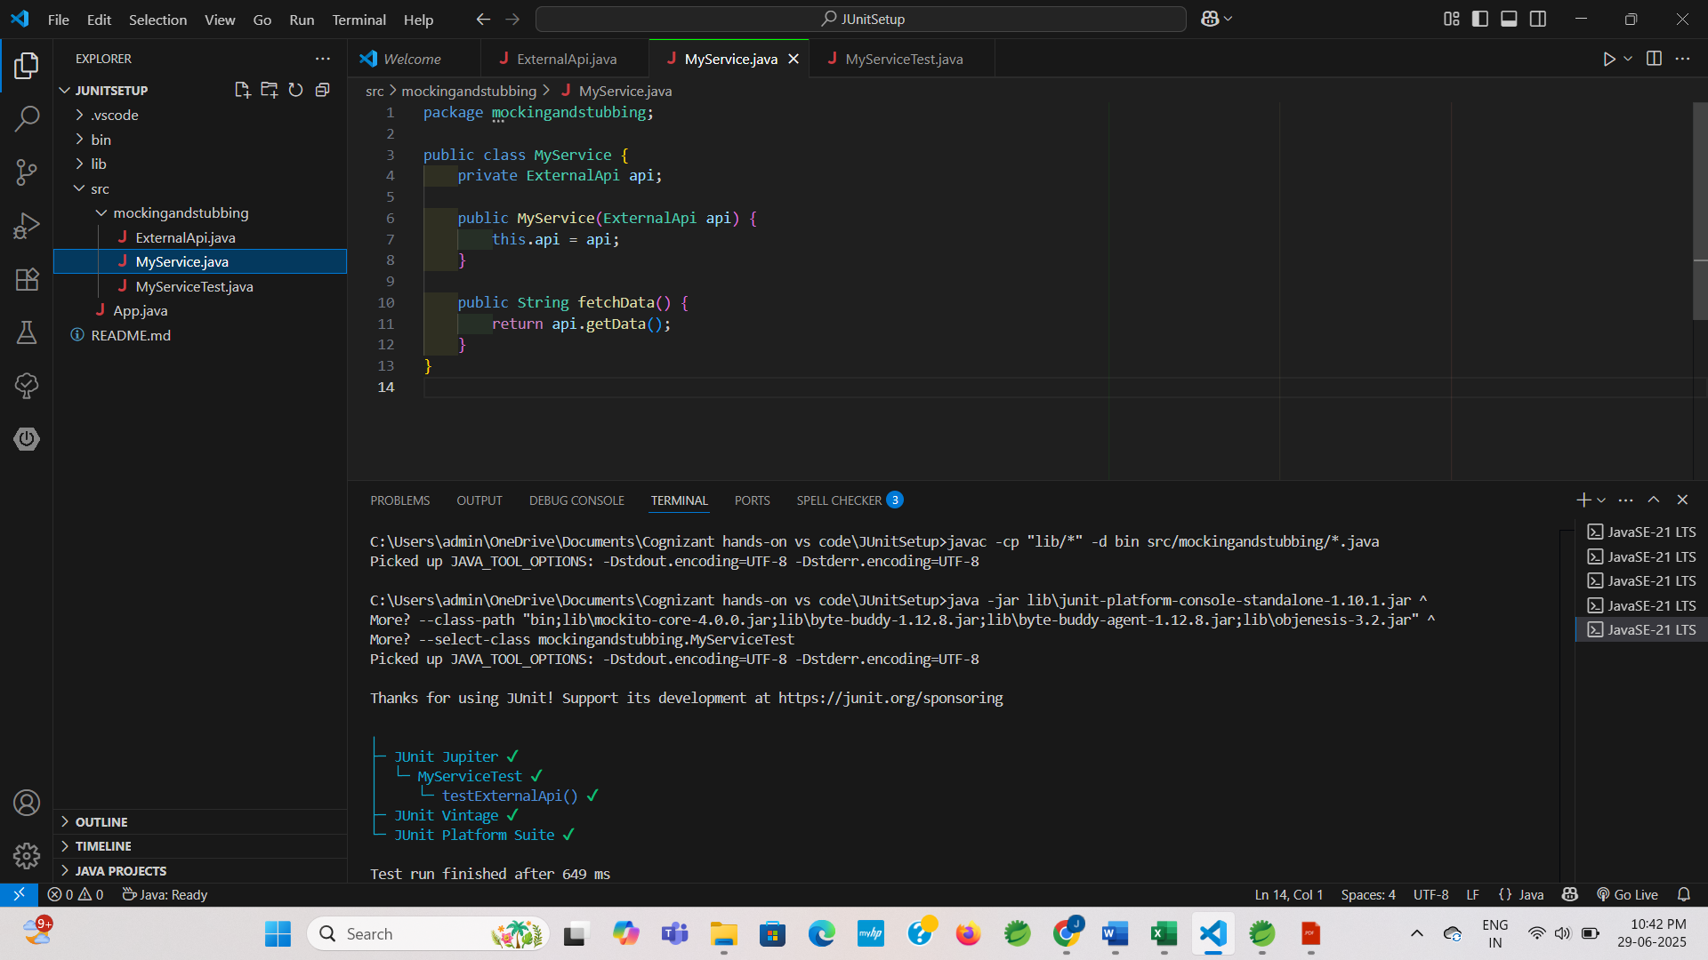

**Step 5: MyServiceTest.java**

**CODE:**

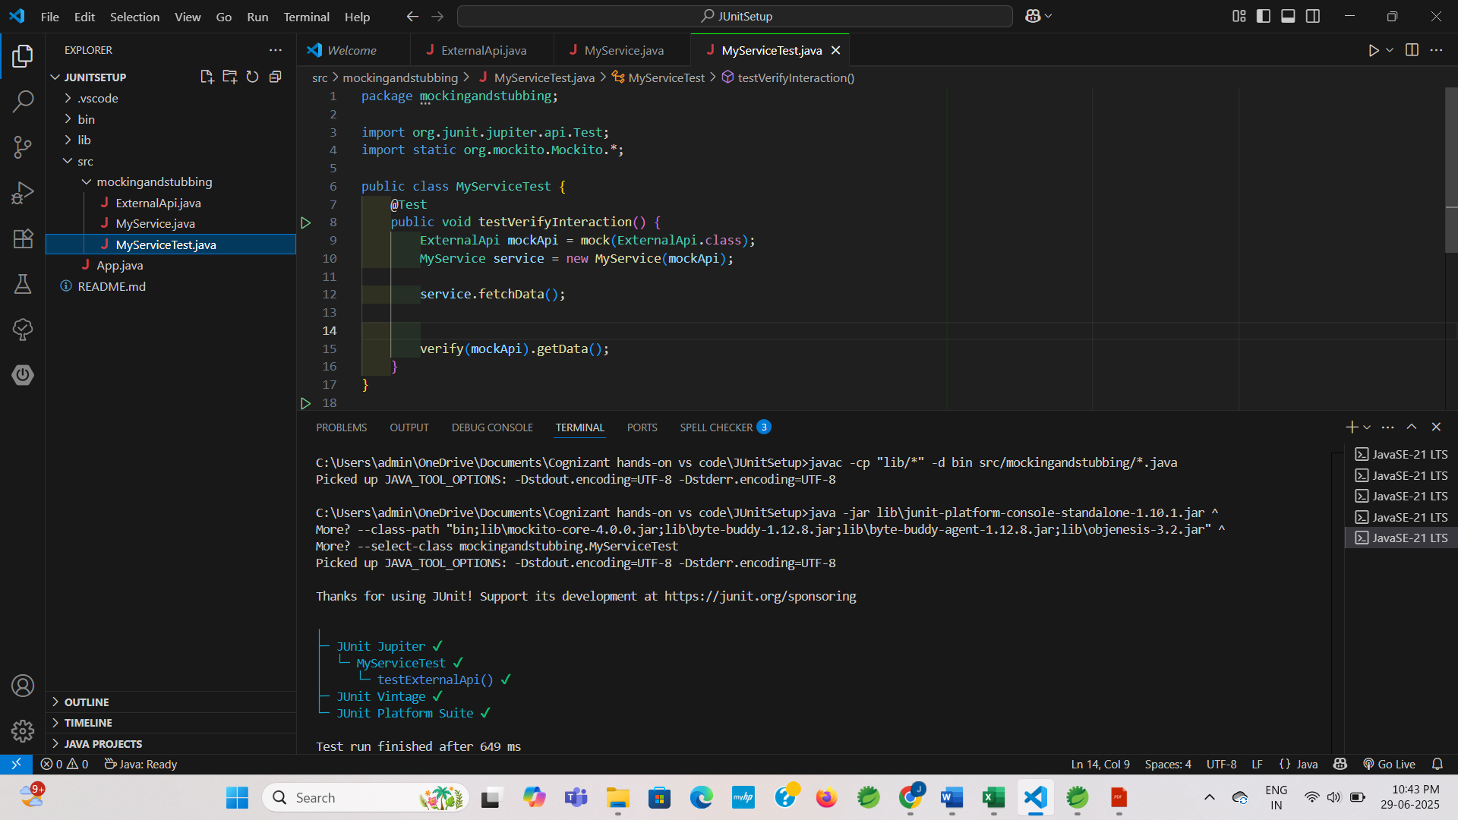

**OUTPUT:**

